ONLINE STUDENT LOGBOOK SUPERVISION MANAGEMENT SYSTEM

ROBERT KASEMBELI – ADM NO. 1034020



**THE CATHOLIC UNIVERSITY OF EASTERN AFRICA**

**FINAL YEAR PROJECT MANAGEMENT SYSTEM**

**PROJECT REPORT**

FOR

COMPUTER SCIENCE DEPARTMENT

FACULTY OF SCIENCE

**BACHELOR OF ARTS**

UNIT CODE: CMT 400

Submitted by

**Robert Kasembeli: ADM NO. 1034020**

UNDER THE GUIDANCE OF

## Mr. Vincent Kibet

(KAREN CAMPUS) BOGANI E RD, NAIROBI KENYA

**2021-2022**

**DECLARATION**

I declare that this written submission represents my ideas in my own words and where others' ideas or words have been included, I have adequately cited and referenced the original sources. I also declare that I have adhered to all principles of academic honesty and integrity and have not misrepresented or fabricated or falsified any idea/data/fact/source in my submission. I understand that any violation of the above will be cause for disciplinary action by the Institute and can also evoke penal action from the sources which have thus not been properly cited or from whom proper permission has not been taken when needed.

-----------------------------------------

(Robert Kasembeli, Roll No: 1034020)

**DEDICATION**

“To my dear father, Collins Milimo Kasembeli who has mentored me in all forms of my being just to thank you for being a blessing.”

**ACKNOWLEDGEMENT**

In successfully completing this project, many people have helped me. I would like to thank all those who are related to this project.

Primarily, I would thank God for being able to complete this project with success. Then I will thank my Supervisor (Vincent Kibet) and coordinator, under whose guidance I learned a lot about this project. His suggestions and directions have helped in the completion of this project.

Finally, I would like to thank my parents and friends who have helped me with their valuable suggestions and guidance and have been very helpful in various stages of project completion.

**ABSTRACT**

*In the past, web servers served static website content; however, over the years major advances have been realized enabling the development of dynamic web applications that enable organizations to harness the power of the Internet for the improvement of service delivery. This project describes the development of an Online Logbook Supervision Management System for the Faculty of Computer Science in the Catholic University of Eastern Africa during Final Year Project Defence.*

*Final Year Project (FYP) is a fundamental piece of university training and an imperative one. This is where the undergraduate is challenged to work on a huge task in term of size and difficulties and it is likewise to prepare them with proper skills to work on future project in the industry. But developing a project is never easy without a logbook to keep track of the project progress. A logbook has always been done on paper but paper-based record system has several major flaws. Thus, in this era of flooded information, a transition to a new platform is relevant which is in this case, an implemented online logbook supervision management system. It is much more mobile, takes no space and much more environmentally friendly.*

*The proposed system intends to ease the administration duties of the main office staff in processing Supervision and Management by making information retrieval and management faster, easier, and more efficient compared to the current manual system. It takes in three types of users Students, Lecturers/Supervisors and Coordinators/Admin and allows concurrent communication among the three parties. In comparison to the conventional use of pen and paper or the use of Email based on the old System, Online Logbook Student Supervision Management System will significantly shorten the time taken by students to complete their projects or dissertations by enabling an Online Student Supervision Management System without the restrictions of time and location. The Online Logbook Student Supervision Management System (OLSSMS) is developed using HTML, CSS, and JavaScript for the front end and PHP for the backend implemented with MySQL database. The working environment used are visual studio code, MySQL workbench and xampp.*

**TABLE OF CONTENTS**

[PAGE TITLE i](#_Toc93058457)

[DECLARATION i](#_Toc93058457)i

[DEDICATION i](#_Toc93058457)ii

[ACKNOWLEDMENT i](#_Toc93058457)v

[ABSTRACT v](#_Toc93058458)

[LIST OF TABLES v](#_Toc93058458)II

[LIST OF FIGURES v](#_Toc93058458)III

[Fig. 8: Data Flow Diagram Level 1 (Teacher) xvii](#_Toc93058459)

**LIST OF TABLES**

|  |  |  |
| --- | --- | --- |
| TABLE NO. | TABLE CAPTIONS | TABLE PAGE |
|  |  |  |
|  |  |  |
|  |  |  |

**LIST OF FIGURES**

|  |  |  |
| --- | --- | --- |
| FIGURE NO. | FIGURE CAPTION | FIGURE PAGE |
|  |  |  |
|  |  |  |
|  |  |  |
|  |  |  |

**LIST OF ABBREVIATIONS(ACRONYMS)**

|  |  |
| --- | --- |
| FYP | Final Year Project |
| UKM | Universiti Kebangsaan Malaysia |
| USER ID | User Identification |
| HTML | Hypertext Markup Language |
| CSS | Cascading Style Sheet |
| PHP | Hypertext Preprocessor |
| AJAX | Asynchronous JavaScript |
| PRINCE2 | Projects IN Controlled Environments |
| V5C | vehicle registration certificate |
| DP | Dynamic Positioning |
| SOLAS | International Convention for the Safety of Life at Sea |
| IMO | International Maritime Organization |
| ELN | Electronic Lab Notebook |
| MARPOL | International Convention for the Prevention of Pollution from Ships |
| NTSA | National Transport and Safety Authority |
| KRA | Kenya Revenue Authority |
| iTax | Income Tax |
| e-logbooks | Electronic Logbooks |

**CHAPTER ONE**

**1.0 INTRODUCTION**

In introducing the research requirement area of this report, chapter one has covered motivation and background research, highlighting how Information Technology (IT) is impacting the society at large, with examples of industries using Information and Communication Technology, covering the issues affecting the domain area of this research project with a brief introduction of what the domain aims at achieving. Background research of the project has been looked at in depth, going ahead to the problem statement of issues affecting the targeted organization. A single sentence of the aim of this research is discussed, leading us to the objectives of this research, next we justify our domain area to why the system is needed, last but not least the scope of research will bring us to the features the proposed system will implement and finally wrap the chapter with report organization that will give a recap summery before introducing chapter two of our literature review.

**1.1 MOTIVATION AND BACKGROUND**

In this era the question revolves around what is IT? And according to techtarget.com Information technology (IT) is the use of any computers, storage, networking and other physical devices, infrastructure and processes to create, process, store, secure and exchange all forms of electronic data. Typically, IT is used in the context of business operations, as opposed to technology used for personal or entertainment purposes. The commercial use of IT encompasses both computer technology and telecommunications.

Kate Smaje, senior partner, McKinsey & Company, states a quote pointing the covid-19 pandemic crisis that “the crisis has forced every company into a massive experiment in how to be more nimble, flexible, and fast.” Mckinsey.com digital states that realization is coming not a moment too soon. Even before the global health crisis hit, 92 percent of company leaders surveyed by McKinsey thought that their business model would not remain viable at the rates of digitization at that time. The pandemic just put that whole scenario on steroids. The companies that are leading the way out of this crisis, the ones that will grab market share and set the tone and tempo for others, are the ones first out of the gate. “The fundamental reality is that the accelerating speed of digital means that we are increasingly living in a winner-take-all world,” Smaje says. “But simply going faster isn’t the answer. Rather, winning companies are investing in the tech, data, processes, and people to enable speed through better decisions and faster course corrections based on what they learn.” Freeport-McMoRan is combining the power of AI and the institutional of its veteran engineers and metallurgists(mineral experts specializing in the extraction of metals from their ores.) to take its operations to another level. Harry “Red” Conger, chief operating officer of the Phoenix-based company, says real-time data is allowing Free-port to lower operating costs, stand more resilient in tough economic climates (and when commodity prices are falling) and make faster decisions. “A learn-fast culture means we put things into action,” he says. “We don’t sit around thinking about it.” Other industries like real-estate house and tenant management, telecommunication service-providers like safaricom and airtel, banking system have revolutionized the world through technology.

The new adaptation of different degree of higher education in Kenya requires that each student develops, presents in public exposition and defend a Final Year Project. Its aim is to demonstrate the skills and knowledge that students have acquired in their studies in order to obtain the attribution to graduate. In this context, the Final Year Project plays a crucial role in the teaching-learning process. It is also a way of identifying the ability of students to perform a final year project or applied research linked to the knowledge discipline. So, this exercise can be considered as a motivation for the students because it allows them choose methods, tools and make decisions during its development. However, some students do not yet have the necessary skills to complete successfully the Final Year Project, which implies an extra-work of their supervisors. Head of Department has an important role as student coordinator in the project development and moreover ensuring that is developed in the right way. Currently keeping this supervision active there is need for a student to be provided with a paper-based logbook that they will use to keep track of their entire development process, feeling in remarks from the respective supervisors at least 5 times a week. The supervisor is assigned students by the coordinator, whose is answered to with project completion to be presented In front of a panel defense.

Developing such kind of a project is never easy without a logbook to keep track of the project progress. A logbook has always been done on paper but paper-based record system has several major flaws.According to Loci Solutions Group Pty Limited, several flaws that is critical in using paper based record system is prone to damage, it could take a significant amount of space as the number of document grow larger, editing problem will occur, since you will need to photocopy the original document first, otherwise it will be ruined with edits and comments. The National Research Council highlights that approximately 500 million cubic meter or 14% of wood harvested worldwide is used for pulp and paper thus it is bad for the environment. The Universiti Kebangsaan Malaysia (UKM) one of the four universities in Malaysia that has been awarded research university status a research conducted in similar domain by them states preliminary observation has shown that for the last five years, an increasing number of students failed to complete their final year project within the allocated time. Although the role of the final year project in Computer Science curriculum is significant, some students (and also supervisors) fail to see its importance. The quality of the prototypes developed has also decreased. This phenomenon is not an isolated case for UKM alone but has been perceived in other universities in the United Kingdom (Bouki 2007) the disease spread to other countries worldwide, affecting our own, fellow students fail to complete the project on time and instead would buy a system they don’t understand or rather have limited time to cram a few functionalities here and there and rush to present with a blind-mind.

Online Student Logbook Supervision Management System (OSLSMS) aims at automating the paper-based logbook to an efficient online supervision. . The following are the advantages of using online logbook:

1. it provides a better storage system and retrieval mechanism
2. it is easier to use
3. it is more secure, since users are authenticated, before they are granted access to the database
4. it provides additional functions like acting as a source of notifying students about information the school wishes to pass.

Logbook is an important mechanism for the Coordinator/Supervisor to evaluate a student's attitude and ability and also to monitor the status of the student's project throughout the semester.

**1.2 BACKGROUND-RESEARCH**

The main aim of this study is to help ease the student to record their final year project progress without having to face the problem that might occur while they are using the paper-based logbook by creating an electronic logbook that has all the essentials of a traditional logbook and also be able to online monitor their final year project in real time so that the supervisors can be able to go through and analyse. To develop a fully functioning Final Year Logbook Management System, one’s need to know about the terms front-end and back-end development. Front-end development: The front-end which is the client side. The front-end is everything that involved with what the user sees. The two core technologies that is used to develop the front-end which is the web pages are HTML, CSS and JAVASCRIPT on the web browser side.

HTML (Hypertext Markup Language) is a language that is used to describe the structure of a web pages. The language gives the authors the means to create online documents with heading, texts, tables, lists and photos. With HTML, the researchers can describe the structure of pages using markup.

CSS (Cascading Style Sheet) work simultaneously with HTML. CSS is a language that describes the presentation of a web page. It includes colors, layout and fonts. CSS allows one to adapt the presentation to different types of devices. CSS is versatile as it can be used directly into HTML document or it can be separated as a CSS stand-alone document.

While those two are the core technologies use to develop a website, there is a third element that will complete the essentials of a modern web pages and it is called JavaScript. “JavaScript is most commonly used as a client side scripting language. This means that JavaScript code is written into an HTML page. When a user requests an HTML page with JavaScript in it, the script is sent to the browser and it’s up to the browser to do something with it”. JavaScript is used primarily to enhance web pages for a more user friendly experience. This means that it involves in dynamically updating web pages and user interface enhancements such as menus, 2 and 3D graphics and video players. Now when those 3 technologies it is called the web page triad in which what are the modern web pages are using.

Back-end development: The back-end or the “server side” is where all the background process of a web page or in another word is how the site works. This refers to everything that the user can’t see in the browser such as databases and servers. Back-end development is required to develop a dynamic site. A dynamic site is a sites that is constantly changing and updated. The most known programming languages that are used by web developers is PHP. PHP (Hypertext Preprocessor) is a server-side scripting language that was used to communicate with the server. The code communicates with the server and then tells the browser what to use from the databases.

Last but not least, more modern tools have emerged to improve on the functionality of web application, some of these tools are not a programming language but more of aiding assistant tools, an example is AJAX (Asynchronous JavaScript and XML) is a set of web development techniques that uses various web technologies on the client side to create asynchronous web applications. With AJAX, web application can send and retrieve data from a server asynchronously (in the background) without interfering with the display and behavior of the recent page. That’s according to Wikipedia. More explanation from the same site, by decoupling the data interchange layer from the present layer, Ajax allows web pages and, by extension, web applications, to change content dynamically without the need to reload the entire web page.

While this are the languages behind the development and design of this project, compatible and most efficient environment are required to create run and manage the codes. Visual studio code will be used for the writing of source code files, (Visual Studio Code is a [source-code editor](https://en.wikipedia.org/wiki/Source-code_editor" \o "Source-code editor) made by [Microsoft](https://en.wikipedia.org/wiki/Microsoft" \o "Microsoft) for [Windows](https://en.wikipedia.org/wiki/Windows" \o "Windows), [Linux](https://en.wikipedia.org/wiki/Linux" \o "Linux) and [macOS](https://en.wikipedia.org/wiki/MacOS" \o "MacOS).[[9]](https://en.wikipedia.org/wiki/Visual_Studio_Code" \l "cite_note-TechCrunch-9) Features include support for [debugging](https://en.wikipedia.org/wiki/Debugging" \o "Debugging), [syntax highlighting](https://en.wikipedia.org/wiki/Syntax_highlighting" \o "Syntax highlighting), [intelligent code completion](https://en.wikipedia.org/wiki/Intelligent_code_completion" \o "), [snippets](https://en.wikipedia.org/wiki/Snippet_(programming)" \o "Snippet (programming)), [code refactoring](https://en.wikipedia.org/wiki/Code_refactoring" \o "Code refactoring), and embedded [Git](https://en.wikipedia.org/wiki/Git" \o "Git). Users can change the [theme](https://en.wikipedia.org/wiki/Theme_(computing)" \o "Theme (computing)), [keyboard shortcuts](https://en.wikipedia.org/wiki/Keyboard_shortcut" \o "Keyboard shortcut), preferences, and install [extensions](https://en.wikipedia.org/wiki/Plug-in_(computing)" \o "Plug-in (computing)) that add additional functionality).

To run the php code on a server we need to install xampp a [free and open-source](https://en.wikipedia.org/wiki/Free_and_open-source" \o "Free and open-source) [cross-platform](https://en.wikipedia.org/wiki/Cross-platform" \o "Cross-platform) [web server](https://en.wikipedia.org/wiki/Web_server" \o "Web server) [solution stack](https://en.wikipedia.org/wiki/Solution_stack" \o "Solution stack) package developed by Apache Friends, consisting mainly of the [Apache HTTP Server](https://en.wikipedia.org/wiki/Apache_HTTP_Server" \o "Apache HTTP Server), [MariaDB](https://en.wikipedia.org/wiki/MariaDB" \o "MariaDB) [database](https://en.wikipedia.org/wiki/Database" \o "Database), and [interpreters](https://en.wikipedia.org/wiki/Interpreter_(computing)" \o "Interpreter (computing)) for scripts written in the [PHP](https://en.wikipedia.org/wiki/PHP" \o "PHP) and [Perl](https://en.wikipedia.org/wiki/Perl" \o "Perl) [programming languages](https://en.wikipedia.org/wiki/Programming_language" \o "). Since most actual web server deployments use the same components as XAMPP, it makes transitioning from a local test server to a live server possible.

**1.3 PROBLEM STATEMENT**

The need for an online logbook for Institutions in their final year project cannot be over emphasized. For a student to gain the required knowledge from project development experiences, he/she must be well monitored to ensure that he/she does not just participate in finishing the course scheme in fulfillment of its mandatory status, but also acquire relevant experiences. The lack of online logbook makes this nearly impossible since distance between students and supervisors and the lack of access to good reference source hinders the actualization of the desired goals, most applicable in the pandemic lockdown in place. Thus aiming at filling the gab of distance and ignorance. More so doing away with paper-based logbook is an advantage to saving space, conserving environment from pulp industries improving efficiency by editing and reducing paper damage. According to National Research Council approximately 500 million cubic meter or 14% of wood harvested worldwide is used for pulp and paper thus it is bad for the environment since it promotes deforestation.

The manual Supervision Management System in use faces several challenges including: -

Time consuming – The current system requires the students to go in person to make appointments, with final their proposals without agreement on the subject with supervisors. Calling or sending email has been known not to yield positive results. This takes up a lot of the students’ time in getting an appointment.

Workload – The manual system is currently maintained by either the staff in the main office or the Lecturers themselves. This increases the workload to the staff unnecessarily.

The previous system was not successful. There were no records of the system in the university. Therefore, it is very important to have a proper management system these days.

There is urgent demand for a system to enable communication between the students and professors' academic staff. The system should allow students and lecturers to communicate with each other more easily and comfortably. The online management system is an interactive system that allows the students ‘academic staff to stay connected, search for project or dissertations and look up suitable supervisor’s valuables professors for research studies.

**1.4 AIM OF RESEARCH**

The main aim of this study is to help ease the student to record their final year project progress without having to face the problem that might occurs while they are using the paper-based logbook by creating an online system that has all the essentials of a traditional logbook.

**1.5 OBJECTIVE OF THE RESEARCH**

The main objectives of the proposed System research will revolve around:

* To give students and lecturers a specific website for students to record their progress.
* Reviewing related system in the market highlighting advantages and disadvantages.
* Coming up with user requirement for the system.
* System analysis of the current system.
* Testing our system for user requirements.
* To bridge the gap between the students and supervisors during the course of the final year project in a pandemic crisis.
* To conserve the environment from deforestation in the pulp industry.
* To generate reports needed by the staff and the access needs of students and lectures.

**1.6 JUSTIFICATION OF RESEARCH**

This research fulfills availability, effectiveness and efficiency of accessing relevant information concerned with student supervision that includes, appointments, submitting report documentation, deploying live system for supervision live review, e-logbook record collection and review, chat communication, registered members, news and constant monitoring.It fulfills the need to make efficient and effective decision-making processes that concern management and operation of student supervision through adaptation of widespread management. The adaptation help the supervision process record retrieval easier and simpler, uploading work in a click of a button and constant communication across the platform through an implemented chat system.

The process is first and efficient by using powerful techniques to achieve every goal, the use of tools like AJAX facilitates dynamic loading of the page to be first. Programming methodology techniques are chosen with care for robust and optimal interpretation of the code on the browser. A well highlighted Entity Relationship Diagram of how storage management is done for efficient resource sharing between users improvising the techniques of physical design of the database schema that is relational and distributed. SQL language will help us achieve the database creation.

This approach of development will cut down future costs imposed on the traditional system, management will improves and efficiency increased. During the search for any existing website for final year project logbook, the results shows that most of the students are using websites such as Word-press and Blog-spot to record their project progress. This shows that there is no specific website for students to record their progress. Thus, the development of this hybrid online system is relevant because there is a need for it.

**1.7 SCOPE OF RESEARCH**

The scope to be covered in this research area are:

* User authentication module for sign-up and sign in utility.
* Student submitting proposal to the directory staff
* Students allocated supervisors
* Student submitting report document.
* Students deploying their domain project name on the web
* Supervisor scheduling appointments
* Supervisor reviewing appointments
* Student requesting appointments
* Student receiving confirmation on requested appointments
* Coordinator accessing student and supervisor records

**1.8 RESEARCH ORGANIZATION**

This project is organized into seven chapters in order, the following paragraph explains more:

The **first chapter** is about the introduction of the project and consists of motivation and background information, research problem statement, aim and objective of the project, as well as significance and scope of the project.

The **second chapter** “methodology” will give information about selected data collection method, the methods of acquiring system requirements and also method for the design, implementation and testing of the system.

The **third chapter**”Literature Review” will consist of summery of different findings about topic and emergent trends related to the online student logbook supervision management system.

The **fourth chapter**”System Analysis” will look at the breakdown of the current system, the system requirement analysis, feasibility study and process logic design of the proposed system.

The **fifth chapter**”System Design” will consist of the prototype model or a description of the proposed system and system architecture and the database design.

The **sixth chapter** will give a detail about system implementation using screen-shots, testing plan and evaluating plan.

The **seventh chapter**”Conclusion, Findings and Recommendations” will consist of summery conclusion of the research project, challenges encountered, future recommendation.

**CHAPTER TWO: REVIEW OF RELATED WORK**

**2.1 CHAPTER INTRODUCTION**

This chapter presents findings from a qualitative research study done by my peer predecessors. It highlights history of the research topic. This is followed by review of related prototypes and systems. It then proceeds to explain the emerging trends and patterns in the research area. The research gap to be filled by the research is briefly outlined. Finally, an overview of the way in which the study was conducted is provided as the chapter summery.

**2.2 HISTORY OF THE RESEARCH TOPIC**

An electronic logbook is defined as a computer-based software program for recording (logging) states, events or simply conditions used for complex machines like air-crafts, nuclear plants, particle accelerators, various areas on board ships replacing paper-based logbook, and many more. This version of logbook was derived from the old-fashioned paper-based logbooks which have been used in the maritime sector. Today a wide spectrum of different implementations of these electronic logbooks is available, even if most versions are based on the classical client-server approach. Here the electronic logbook serves a client, which is in most cases a simple web browser.

It is better to understand the main vocabulary “logbook” from its origin: The term logbook originating with the ship’s log, a log of important events in the management, operation, and navigation of a ship. Some of the uses it has been applied include:

* Aircraft pilots must maintain a pilot logbook to record their time spent flying and in a simulator. In addition, aircraft operators must maintain an aircraft technical logbook (or “techlog”) recording the aircraft’s flights.
* In a project, a logbook is a recording which is compiled while it is being done, may be called a project diary. In the PRINCE2 project management framework, daily logs are used to record issues, actions or events not caught by other types of registers or logs within the framework. Examples of other logs or registers in PRINCE2 include the lessons log, risk register, issue register, quality register or backlog.
* In skydiving logbook serves as a parachutist's personal history in the sport and also serves as an identifying document. It also provides drop zones to back one's skydiving licenses, ratings and currency.
* In scuba diving, the dive log documents the experience of a diver by logging a diver's dives.
* In the fishing industry, a logbook is used to record catch data as part of the fisheries regulations. It is then submitted to the fishing authorities of the vessel's flag state.
* For amateur radio, the logbook is where the hams register their contacts and other radio operations. There are several programs to help radio operators in the management of their logbook.
* For commercial vehicles: In Canada, the United States, New Zealand and other countries, a logbook is used to register driver and operator work time for commercial heavy vehicles. In the United States hours of service are recorded in a logbook. In New Zealand it is referred to as work-time.
* In the United Kingdom, a vehicle registration certificate (V5C) and service history is often referred to as a "logbook".
* A race car log book is a document certifying that a car is prepared to a given set of rules and is safe for competitions.

The discovery of logbook is growing spontaneously from paper-work to electronic making diverse industries adopt the concept with a lot of passion and focus, some of the evolutions written in history include: Marine Electronic Logbook, Electronic Shift Logbook and Electronic Lab Logbooks. Nowadays we have Educational Purpose logbooks for institutions when students go for Industrial attachments they are given an Attachment Logbook to fill in their progress and supervisions. During Final year, students in their final year are engaged in research projects that require them to have a logbooks and record all the progress of their project as a proof of consistency and honest work and also as a way of receiving guidance on how to do their research for writing a report on the proposed project, with this they are issued with a Research Project Log Book which is the proposed project of this research.

**2.3 REVIEW OF RELATED PROTOTYPES, SYSTEMS**

The focus area is interesting as one is able to know what has been done by other users and implement it their project. The cases of related work help one fathom what went well for other researchers and what didn’t go well for them. It helps us familiar with other cases of study and how they outlined their research study.

**2.3.1 GLOBAL REVIEWS**

Here we go international, worldwide research methods for the related project research.

**2.3.1.1 Marine Electronic Logbook**

An electronic alternative to record key navigation, engine watch, port calls and other operational activities on board vessels of all sizes. Marine electronic logbooks must meet the specific reporting requirements of IMO, SOLAS and flag states. Manually inserted information is normally combined with data recorded from the vessel's instruments such as time and position. Typical marine electronic logbooks are:

* Deck logbook – Records navigational events related to the voyage and operations on board
* Dynamic positioning logbook – Manual recording of operations related to Dynamic Positioning (DP) operations
* Engine logbook – Records engine events related to the engine and machinery operation
* Oil record book – Records events related to oil and dirty water as required by IMO's MARPOL convention
* Operational log – Records events related to vessel operation, i.e. performance, cargo handling and maritime operations. The Operational Log will typically need some customization to owner's requirement and trade.
* Radio logbook – Records events relevant to radio traffic as required by IMO and the flag states

**2.3.1.2 Electronic Shift Logbook**

On any industrial site, there is a continuous stream of operational, maintenance and safety events occurring at all levels and areas within the process. An electronic shift logbook is used at power plants and in process industry where several shift teams cooperate in maintaining production. Typically, the electronic shift logbook is used to record state at the production plant, but it can also contain simple planning functions that notify personnel about upcoming maintenance activities. Compared to the paper logbook the electronic shift logbook enhances the value of the gathered information through:

* Search functions
* Defined plant hierarchy for registration of logbook entries
* Classification according to certain entry types
* Statistics about most problematic areas
* Management reports

**2.3.1.3 Electronic Lab Notebook**

An electronic lab notebook (also known as electronic laboratory notebook, or ELN) is a computer program designed to replace paper laboratory notebooks. Lab notebooks in general are used by scientists, engineers, and technicians to document research, experiments, and procedures performed in a laboratory. A lab notebook is often maintained to be a legal document and may be used in a court of law as evidence. Similar to an inventory’s notebook, the lab notebook is also often referred to in patient prosecution and intellectual property litigation.

Electronic lab notebooks offer many benefits to the user as well as organizations; they are easier to search upon, simplify data copying and backups, and support collaboration amongst many users. ELNs can have fine-grained access controls, and can be more secure than their paper counterparts. They also allow the direct incorporation of data from instruments, replacing the practice of printing out data to be stapled into a paper notebook.

**2.1.1 LOCAL REVIEWS**

Generally, in Africa advanced hotels and restaurants uses online logbooks to keep their loggings. A recent survey shows that close to 100% of hotels and restaurants keep logbooks. Of those, 100% rank the tracking of customer issues as most important, followed by maintenance issues and staffing issues (97% and 79% respectively). Unfortunately, manual logbooks or email threads make it difficult to track issues through follow-up actions. Customized systems are built with in-built logbooks that builds all that in, and more.

**2.3.2.1 Mogo – Logbook Loans**

MOGO is a topnotch financial service provider with active presence in more than 17 countries in the world, mainly in Europe, Asia and Africa. Customers are provided with auto logbook loans that allow them to money quickly and continue driving their cars. Locally Mogo in Kenya is located in the following regions, Nairobi, Mombasa, Nakuru, Eldoret and Kisumu.

**2.3.2.2 Bees Credit – Logbook Loans**

Bees Credit Limited is a credit-only Micro-Finance Company Licensed in Kenya under the Company’s Act. The company, was founded with a vision to provide affordable access to financial services to the underserved underbanked market in Africa. The company offers logbook loans and assets financing loans to customers within 24 hours being a hassle free and convenient.

**2.3.2.3 NTSA Logbook**

National Transport and Safety Authority is a state corporation under the Ministry of Transport and Infrastructure. It was established through an Act of Parliament; Act Number 33 of 2012. The objective of forming the Authority is to: Harmonize the operations of the key road transport departments which were previously handled by various government departments, effectively manage the road transport subsector and Minimizing loss of lives through road crash.

The company has logbooks for the clients who wish to transfer vehicle ownership or do a logbook search of the ownership a particular vehicle or motorist. Logbook transfer of ownership occurs many times in our country. This happens mostly when someone wants to sell his or her motor vehicle. However, before the vehicle becomes yours, you are required to do Logbook transfer which will verify the car ownership. Note that the requirements of the National Transport and Safety Authority- NTSA logbook transfer differ from each category ranging from an individual to a company to business.

The NTSA Tims logbook transfer online system lets real-time transfer of vehicles without necessarily presenting any physical paperwork to the regulator.

**2.3.2.4 KRA Logbook**

Kenya Revenue Authority (KRA), is an agency of the [Government of Kenya](https://en.wikipedia.org/wiki/Government_of_Kenya" \o "Government of Kenya) that is responsible for the assessment, collection and accounting for all revenues that are due to government, in accordance with the laws of Kenya. Accessing and logging into the KRA Portal or iTax is one of the most important things for any Kenyan with an active KRA PIN Number issued by Kenya Revenue Authority (KRA). To be able to Login to KRA Portal or iTax, there are a set of requirements that you need to ensure that you have with you. This includes; KRA PIN Number and KRA Password (iTax Password). These two requirements play an important role as you will need them in order to login to KRA Portal so as to be able to access the variety of options, functionality and tasks on the KRA Portal.

The KRA logbook are available for search, when necessary, by the Kenyan Citizen, providing compliance and reliability.

**2.4 EMERGING TRENDS AND PATTERNS IN THE RESERACH AREA**

E-logbooks date back to the origin of maritime sector, since then a wide spectrum of different implementations of these logbooks are available. Different uses have been put in place just to mention a few: Marin Electronic Logbooks; Electronic Shift Logbooks and Electronic Lab Notebook. Generally, it becomes a huge problem to have a single logbook to cater for a complex industry like Marine Electronic Logbook that needs to be broken down into specific logbooks with specific functions. For example, Deck logbook – Records navigational events related to the voyage and operations on board. Dynamic positioning logbook – Manual recording of operations related to Dynamic Positioning (DP) operations. Engine logbook – Records engine events related to the engine and machinery operation. Oil record book – Records events related to oil and dirty water as required by IMO's MARPOL convention. Operational log – Records events related to vessel operation, i.e., performance, cargo handling and maritime operations. The Operational Log will typically need some customization to owner's requirement and trade. Radio logbook – Records events relevant to radio traffic as required by IMO and the flag states.

In an era, full of information and a vast growing technology, today many companies and individual people are seeing the importance of logbooks, traditionally paper-logbook were more preferred but technology is making online logbooks be more reliable, saving on space and reducing paper damage. Logbook Loans have been implemented in Kenya to issue out fast way of getting money and paying bills. NTSA Logbooks are helping government and citizens manage their vehicles and licenses. KRA Logbooks are keeping Citizen's log files making it easy for the customers to gain access easily. Some of the trends today include news from NTSA. The National Transport and Safety Authority (NTSA) director-general Francis Meja has announced plans to introduce electronic logbooks (e-logbooks) to curb vehicle ownership related fraud. In a statement, Meja said that the move will improve information sharing through its online register, the Transport Integrated Management System (TIMS). “We are currently reviewing the option of having electronic logbooks that can be easily verified through the system and also seeing how the system can be integrated with insurance firms to know who actually has insured their vehicle,” stated Meja. According to Meja, the e-logbook and the system will reduce instances of fraud by allowing financial institutions to view their financed assets electronically. The move follows an incidence last year where insurers were conned billions by con artists who were using fake car logbooks to swindle insurers out of millions of shillings. The cartel, suspected to consist of about 10 scammers, had managed to infiltrate the NTSA’s online database, compromising the integrity of vehicle registration details.

Similar research report of the proposed project was done in the university of Portsmouth. Stating that in higher education, logbooks are a commonly used tool thought to be one that encourages active independent learning and reflective thinking. In School of Engineering, at University of Portsmouth, paper and more recently online logbooks have been in use for recording work for final year projects and project-based learning tasks. The work presented here benefits from a unique opportunity within the School of Engineering, where online logbooks alongside traditional paper-based logbooks are being used within final year projects. A recent cohort of students (N=127) on ENG600 project module was given the option, through their supervisors, to use paper logbooks and or online logbooks for recording their work. This work aims to investigate the use of both paper and online logbooks. A mix of Qualitative Research methods and quantitative techniques will be used in this project. The use of content analysis will provide an insight into student reflections and their motivations for using their logbook. Furthermore, focus groups, involving live editing of documents in an individual and collaborative fashion, will be used to gather more data for analysis. Quantitative methods (questionnaire, analytics and quantitative content analysis) will also be used in this study. When this work is completed, it will provide guidance and comparison on using the two types of logbooks, backed by knowledge of student motivations and approaches.

* + 1. **Weaknesses**

This project is a study of the usability of electronic logbook and is therefore may not give or meet every expectation. The main focus of the project is to develop a system for reporting IT activities within the university community, other than the paper logbook. Other extended functionality may not therefore be included or where they are, may lack some expected features. Some of the extended features may include:

The ability to tell the number of weeks a student submits his/her weekly work by increment a value every time the student submits her work.

The ability to search the web interfaces through a search field may not be possible since the pages are not so many as to warrant a search field.

* + 1. **Strengths**

The following are the advantages of using electronic logbook.

It provides a better storage system and retrieval mechanism  
It is easier to use  
It is more secure, since users are authenticated, before they are granted access to the database  
It provides additional functions like acting as a source of notifying interns about information the school wishes to pass.

**2.2 RESEARCH GAP TO BE FILED BY THE PROPOSED RESEARCH**

A research gap is a question or a problem that has not been answered by any of the existing studies or research within your field. Sometimes, a research gap exists when there is a concept or new idea that hasn't been studied at all. Sometimes you'll find a research gap if all the existing research is outdated and in need of new/updated research (studies on Internet use in 2001, for example). Or, perhaps a specific population has not been well studied (perhaps there are plenty of studies on teenagers and video games, but not enough studies on toddlers and video games, for example). These are just a few examples.

There is a trending growth and innovation in the field of Internet of Things(IoT), Artificial Intelligence and Machine Learning. This technologies are meant to revolutionize the human world to a much better connected simultaneous interaction of modules and avatars. As we have seen with the development of the E-logbook from the ships logbook diversifying to many ideas behind record keeping paper-based logbook, smart systems that are able to store retrieve and update in real time system have been put into place.

The research has shown that there are very few areas that a logbook extends to concentrate on, even in a single industries there is a requirement to have separate logbook modules specialized to one simple task. An example given earlier was that generally, it becomes a huge problem to have a single logbook to cater for a complex industry like Marine Electronic Logbook that needs to be broken down into specific logbooks with specific functions. For example, Deck logbook – Records navigational events related to the voyage and operations on board. Dynamic positioning logbook – Manual recording of operations related to Dynamic Positioning (DP) operations. Engine logbook – Records engine events related to the engine and machinery operation. Oil record book – Records events related to oil and dirty water as required by IMO's MARPOL convention. Operational log – Records events related to vessel operation, i.e., performance, cargo handling and maritime operations. The Operational Log will typically need some customization to owner's requirement and trade. Radio logbook – Records events relevant to radio traffic as required by IMO and the flag states.

This kind of concept is the reason why logbooks have been diversified into solving problems at once and quick as logbook concentrate on specific tasks, small businesses are used to using applications like Microsoft word and excel to store record in files systems. Other industries use manual system of storing files in cabinets.Manual filling system used to hold so many files well labeled and store in one more cabinets. Sometimes these cabinets used to have locks to enhance and could be located in secure areas of the organization as a security measure. The main challenge associated with manual file based approach is cross reference information across more than one file. For example, we may have a department named registry in a college/university and it keeps information about the students. At the same university, we have a department named accounts which keeps track of student school payment. Consider how it will be hard to generate the following reports. ß Which student has paid the school fees? ß How many units has the student registered?.

The manual Supervision Management System in use faces several challenges including: -

Time consuming – The current system requires the students to go in person to make appointments, with final their proposals without agreement on the subject with supervisors. Calling or sending email has been known not to yield positive results. This takes up a lot of the students’ time in getting an appointment.

Workload – The manual system is currently maintained by either the staff in the main office or the Lecturers themselves. This increases the workload to the staff unnecessarily.

The previous system was not successful. There were no records of the system in the university. Therefore, it is very important to have a proper management system these days.

There is urgent demand for a system to enable communication between the students and professors' academic staff. The system should allow students and lecturers to communicate with each other more easily and comfortably. The online management system is an interactive system that allows the students ‘academic staff to stay connected, search for project or dissertations and look up suitable supervisor’s valuables professors for research studies.

Paper-based logbook has proved incompetence, difficult to edit, prone to damage and lost. Also the availability of online logbook in this research area are very limited, the area has not been concentrated much when it come to final year defence project in institution. The proposed system aims at helping ease the student to record their final year project progress without having to face the problem that might occurs while they are using the paper-based logbook by creating an online system that has all the essentials of a traditional logbook.

**2.3 CHAPTER SUMMERY**

The chapter starts off by presenting the history of the research topic. This is followed by review of related prototypes and systems (from global to local). It then proceeds to explain the emerging trends and patterns in the research area. The research gap to be filled by the research is briefly outlined.

**CHAPTER THREE: RESEARCH METHODOLOGY**

**3.1 CHAPTER INTRODUCTION**

This chapter includes the research methodology of the dissertation. Therefore, we will outline the strategy and approach together with methods of data collection, selection of the sample research process and types of data analysis, the ethical consideration and the research limitation of the project.

**3.2 METHODOLOGY FOR LITERATURE REVIEW**

Most of the web developers company are using web development process called Web Development Life Cycle (WDLC). WDLC follows the same concept as Software Development Life Cycle (SDLC) model using a waterfall approach. However, by incorporating prototyping methodology, the WDLC becomes repetitious process involving the users through the development process. By dividing the graphical development and also the functional development into complete different stages, every of those set of phases may be worked on consecutively or the same time. WDLC consists of 5 phases which is planning, analysis, design and development, testing and implementation and maintenance. Figure 1 shows the Web Development Life Cycle.

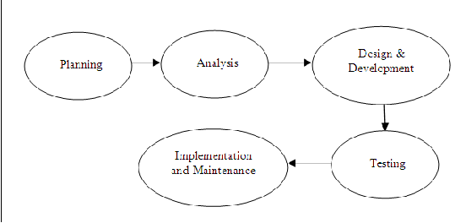

Fig. 1: WDLC

Our literature review in this research will apply case studies methodology. This approach will aim to analyse a variety of aspects surrounding online student supervision management system, different entities involved with the supervision processes and challenges facing the supervision process in the era of technology applications.

The following will apply categories of case studies:

* Descriptive case study
* Exploratory case study
* Explanatory case study

While applying descriptive case study, we will try to establish the impact of online student logbook supervision at community level and its ability to bring social value to enhance the supervision process. The interest in supervision will be determined by the proposed projects done by the students, approval from the respective supervisors and general co-ordination from the Head of Department. In this way the researcher will establish key points on how to engage those entities in interviews by structuring interview questions accordingly. This is inline with observation as data collection method which will capture the imagination of online supervision.

Explanatory case study will take into account responses from interviewees who will be online logbook supervision entities. Therefore students, head of office, lecturers or respective supervisors will answer a few questions drawn from a compilation of case points that the researcher will use to design the interview questions. This interviews will help the researcher comment the imagination of interviewees in a manner such that to capture the correct description of their understanding of logbook supervision processes and management at community level.

The main source of materials needed for this project will be from books and articles or journals and supervision related forms found online and library resources. These material will grant explanatory case studies into the application of technology to manage processes and how they can be applied to increase efficiency in normal daily operations with the student supervision.Materials referenced will be 8yeras and above for the system to be more up to date and current with requirements of emerging trends in online logbook supervision.

**3.3 METHODOLOGY FOR REQUIREMENT SPECIFICATION, DATA COLLECTION AND ANALYSIS TECHNIQUES.**

To develop this system, we will require a clear communication and response from use cases who will interact firsthand with it. Their feedback is crucial in underlining their needs and expectations to be implemented into the system. The use cases will influence the design of bespoke features and modules that assist in day-to-day operations of student supervision. It is important to note that human user interactions with this system should give them access to more than productive and satisfied.

Therefore, we will conduct data collection through interviews, evaluation of forms and observations into various similar software products that capture the dynamics of student supervision. Based on findings from our requirements questionnaire we will establish and analyse what the entities will need to be reflected from the software design. Use case analysis will generate description of actors, use cases, use case scenarios, and other extra information needed to represent the use cases. Use case analysis can simplify a concept and system appearance to technical and non-technical users.

The following is a breakdown of the various data collection techniques that will be utilized in this research to find user requirements:

* **Interview:** interviews are used to collect a wide source of information about attribute, behaviour, norms,, preferences, attitude, opinions, and knowledge. Interviewing will help understand better the subjects of this research who are invested in final year project supervision for students and lecturers. The application mode of data collection in this research will be face-to-face interviews while phone and online meetings are subsidiary modes. Regardless of this method being expensive than others, the reason why this method will be selected is that it will allow the researcher to obtain detailed information about personal perceptions and opinions from final year project supervision participants.
* **Questionnaires:** some forms that are essential in final year supervision management capture will be evaluated and relevant ideas borrowed from them. These include project proposal forms, student and lecture assigned forms, appointment forms, project defence evaluation forms, meeting attendance forms as well as monitoring and communication to students and lecturers with relevant information and updates. This method has been chosen because it allows the researcher to get specific detail about items that will be used in the system and the output/reports of some basic operations.
* **Observation:** observation involves collecting information without asking questions. This method is more subjective, as it requires the researcher or observer to add their judgement to the data. But in some circumstances, the risk of bias is minimal. This method will also be selected because, it will allow the researcher to collect data while taking in consideration all the possibilities of implications that only the system developer can find; furthermore it can determine the dynamics of a situation, which generally cannot be measured by other methods of data collection. Therefor we will engage in observing normal operation and management procedures that final year online logbook supervision engage in, how the participants are responsible and maintaining the relevant theme. Document analysis will be used to gather data from relevant prior researches.

**3.4 METHODOLOGY FOR SYSTEM ANALYSIS(CURRENT SYSTEM)**

During the analysis phase, team members will make decisions on what to put in the system which is the content and functionality. To help define the appropriate system content and functionality, first the need to identify the tasks needed by users to perform. The students need to assess all the software, hardware and data needed in order to develop a system.

From the research conducted for related projects, majority of the school logbooks are based on attendance management system that monitors the logs for attendance for students, employees, visitors and teachers. The admin section views all the management for students, faculty, employees and visitors and the logs for each. This system is taken as a reference to the proposed system for they both have the same goal of doing away with paperwork and achieving online record keeping.

**3.4.1 Data Flow Diagram**

A data flow diagram shows the way information flows through a process or system. It includes data inputs and outputs, data stores, and the various sub-processes the data moves through. DFDs are built using standardized symbols and notation to describe various entities and their relationships.

Data flow diagrams will visually represent systems and processes that would be hard to describe in a chunk of text.

**3.4.2 Unified Modelling Language(UML)**

The Unified Modeling Language (UML) is a language used in the field of software engineering that represent the components of the Object-Oriented Programming concepts. It is the general way that will aid us to define the whole software architecture or structure.

In Object-Oriented Programming, we solve and interact with complex algorithms by considering themselves as objects or entities. These objects can be anything. It can be the bank or a bank manager too. The object can be a vehicle, animal, machine, etc. The thing is how we interact and manipulate them that they can perform tasks and they should.

The tasks can be interacting with other objects, transferring data from one object to another, manipulating other objects, etc. The single software could have hundreds or even thousands of objects. So, UML provides us a way to represent and track those objects in a diagram to become a blueprint of our software architecture.

**3.4.3 Flowcharts**

A flowchart is a picture of the separate steps of a process in sequential order. It is a generic tool that can be adapted for a wide variety of purposes, and can be used to describe various processes, such as a manufacturing process, an administrative or service process, or a project plan.

Our system will adapt flowchart process to show the work-flow objectives and goals.

**3.4.4 Use Case Diagrams**

A [UML](https://en.wikipedia.org/wiki/Unified_Modeling_Language" \t "https://www.visual-paradigm.com/guide/uml-unified-modeling-language/what-is-use-case-diagram/_blank) use case diagram is the primary form of system/software requirements for a new software program underdeveloped. Use cases specify the expected behavior (what), and not the exact method of making it happen (how). Use cases once specified can be denoted both textual and visual representation (i.e. use case diagram). A key concept of use case modeling is that it helps us design a system from the end user's perspective. It is an effective technique for communicating system behavior in the user's terms by specifying all externally visible system behavior.

**3.5 METHODOLOGY FOR SYSTEM DESIGN(PROPOSED SYSTEM)**

System design methodology is a technique that is used to show the proposed system will be developed, it covers the process of defining the architecture, modules, interfaces and data for a system to satisfy specified requirements.

A **program flowchart** is a data flow that shows the data flow while writing a program or algorithm. It allows the user to explain the process quickly as they collaborate with others. These programming flowcharts also analyze the logic behind the program to process the code of the programming. The programming flowcharts can serve in different ways. For example, they can analyze the codes, visualize and work on them. They can also help figure out the application's structure to realize how a user navigates in a tool. The programming flowcharts improve the condition and efficiency of work. The tool has four basic symbols that have code written on them for programming. They give commands like start, process, decision, and end, and these symbols are the crucial part of the programming flowcharts. They help in forming a relationship between various elements to describe the data flow.

An **Entity–relationship model (ER model)** describes the structure of a database with the help of a diagram, which is known as Entity Relationship Diagram (ER Diagram). An ER model is a design or blueprint of a database that can later be implemented as a database. The main components of E-R model are: entity set and relationship set .An ER diagram shows the relationship among entity sets. An entity set is a group of similar entities and these entities can have attributes. In terms of DBMS, an entity is a table or attribute of a table in database, so by showing relationship among tables and their attributes, ER diagram shows the complete logical structure of a database. Lets have a look at a simple ER diagram to understand this concept.

A **sequence diagram** is a type of interaction diagram because it describes how—and in what order—a group of objects works together. These diagrams are used by software developers and business professionals to understand requirements for a new system or to document an existing process. Sequence diagrams are sometimes known as event diagrams or event scenarios.

A **data flow diagram (DFD)** maps out the flow of information for any process or system. It uses defined symbols like rectangles, circles and arrows, plus short text labels, to show data inputs, outputs, storage points and the routes between each destination. Data flowcharts can range from simple, even hand-drawn process overviews, to in-depth, multilevel DFDs that dig progressively deeper into how the data is handled. They can be used to analyze an existing system or model a new one. Like all the best diagrams and charts, a DFD can often visually “say” things that would be hard to explain in words, and they work for both technical and nontechnical audiences, from developer to CEO.

Flowcharts, DFD, Sequence diagram and ERD are easy and efficient to design and implement in order to explain the system design.

**3.6 METHODOLOGY FOR SYSTEM IMPLEMENTATION**

Systems implementation is the process of: defining how the information system should be built (i.e., physical system design), ensuring that the information system is operational and used, ensuring that the information system meets quality standard (i.e., quality assurance).

**3.6.1 Process Logic**

The database will be implemented using XAMPP; is a free and open-source cross-platform web server solution stack package developed by Apache Friends, consisting mainly of the Apache HTTP Server, MariaDB database, and interpreters for scripts written in the PHP and Perl programming languages. Since most actual web server deployments use the same components as XAMPP, it makes transitioning from a local test server to a live server possible. XAMPP's ease of deployment means a WAMP or LAMP stack can be installed quickly and simply on an operating system by a developer, with the advantage a number of common add-in applications such as Wordpress and Joomla! can also be installed with similar ease using Bitnami.

XAMPP is an abbreviation where X stands for Cross-Platform, A stands for Apache, M stands for [MYSQL](https://www.javatpoint.com/mysql-tutorial), and the Ps stand for PHP and Perl, respectively. It is an open-source package of web solutions that includes Apache distribution for many servers and command-line executable along with modules such as Apache server, [MariaDB](https://www.javatpoint.com/mariadb-tutorial), PHP, and Perl.

XAMPP helps a local host or server to test its website and clients via computers and laptops before releasing it to the main server. It is a platform that furnishes a suitable environment to test and verify the working of projects based on Apache, Perl, MySQL database, and PHP through the system of the host itself. Among these technologies, [Perl](https://www.javatpoint.com/perl-tutorial) is a programming language used for web development, [PHP](https://www.javatpoint.com/php-tutorial) is a back-end scripting language, and MariaDB is the most vividly used database developed by MySQL. The detailed description of these components is given below.

Primary focus is on **phpMyAdmin:** It is a tool used for dealing with MariaDB. Its version 4.0.4 is currently being used in XAMPP. Administration of DBMS is its main role. **Followed** by ****PHP:**** It is the backend scripting language primarily used for web development. **PHP** allows users to create dynamic websites and applications. It can be installed on every platform and supports a variety of database management systems. It was implemented using C language. PHP stands for Hypertext Processor. It is said to be derived from Personal Home Page tools, which explains its simplicity and functionality.

**3.6.2 Database Design**

Database design can be generally defined as a collection of tasks or processes that enhance the designing, development, implementation, and maintenance of enterprise data management system. Designing a proper database reduces the maintenance cost thereby improving data consistency and the cost-effective measures are greatly influenced in terms of disk storage space. Therefore, there has to be a brilliant concept of designing a database. The designer should follow the constraints and decide how the elements correlate and what kind of data must be stored.

The main objectives behind database designing are to produce physical and logical design models of the proposed database system. To elaborate this, the logical model is primarily concentrated on the requirements of data and the considerations must be made in terms of monolithic considerations and hence the stored physical data must be stored independent of the physical conditions. On the other hand, the physical database design model includes a translation of the logical design model of the database by keep control of physical media using hardware resources and software systems such as Database Management System (DBMS).

**3.6.3 I/O Design**

It is important to design appropriate data input methods to prevent errors while entering data. These methods depend on whether the data is entered by customers in forms manually and later entered by data entry operators, or data is directly entered by users on the PCs.

The system should make sure to prevent user from making mistakes by −

* Clear form design by leaving enough space for writing legibly.
* Clear instructions to fill form.
* Clear form design.
* Reducing key strokes.
* Immediate error feedback.

Some of the popular data input methods are −

* Batch input method (Offline data input method)
* Online data input method
* Computer readable forms
* Interactive data input

**3.7 METHODOLOGY FOR SYSTEM TESTING**

Testing is one of the most routine part of the system development. In this phase, every single link will be tested in order to avoid any broken or dead links. Every script that is used in the system should be tested for its functionality. Check of the system has cross-browser compatibility and should be made to cater all types of devices. After all the check and recheck, the system is finally ready to be uploaded into the server and final test should be done after the system was deployed into the server, in this phase the need to check all the buttons to make sure all the scripts coded are functioning as well. The check for integrity of the database is considered in order to avoid conflict when it comes to the user account. All tables in the system should be related and the primary key need to be defined.

|  |  |  |
| --- | --- | --- |
| **Test** | **Description** | **Characteristics** |
| Inspection | Manually examine code for errors | Detect 60-90 percent of defects |
| Walk-through | Manually review codes to find errors by examining what the code does | Should be done when the process of work are small |
| Desk Checking | Manually work through the code, executing each instructions using test cases | The reviewer acts as a computer |
| Syntax checking | Uncover syntax errors by compilers | The only automatic testing technique that is static |
| Unit/Module Testing | Discover any error that may exists in a module’s code | Each module is tested alone |
| Integration Testing | Discover any errors that may exist by combining modules | Top-down gradual testing |
| System Testing | Discover any errors that may exist by integrating programs into systems | Top-down gradual testing |

**3.8 METHODOLOGY FOR SYSTEM DEPLOYEMENT**

This is the final phase of WDLC and SDLC. Point to remember is that a system is more service than a product. Regular updates should be done to decrease security risks and bug. Feedback system should be added, to allow the user to report any bug whether it is critical or not to ensure that the system can be used into fully extend. This is the phase where thorough observation is done for the working of the system and necessary adjustment are done in case of any error.

**3.9 CHAPTER SUMMERY**

The whole of chapter two has highlighted the methodology of literature review, requirement specifications, system analysis and design of current and proposed system respectively, system implementation and testing of the working progress and finally the deployment methods used and measures put in place at the final stage.

**CHAPTER 4: SYSTEM ANALYSIS**

**4.1 CHAPTER INTRODUCTION**

Systems analysis is a problem-solving method that involves looking at the wider system, breaking apart the parts, and figuring out how it works in order to achieve a particular goal. A system is a general set of parts, steps, or components that are connected to form a more complex whole. For example, a computer system contains processors, memory, electrical pathways, a power supply, etc. For a very different example, a business is a system made up of methods, procedures, and routines.

This project makes use of SSADM (Structured systems analysis and design method). The SSADM is classified as a Waterfall Model. With Waterfall Model, analyst and users proceed sequentially from one phase to the next and each phase can be mapped out and evaluated (Henver, 2004). First of all, the feasibility study is done. Once that part is over the requirement analysis and project planning begins. The design starts after the requirement analysis is complete and the coding begins after the design is complete. Once the programming is completed, the testing is done.

This chapter highlights the description of the current system, its strength and weaknesses, the requirement analysis, feasibility study and its conclusion, more discussion is elaborated into requirement analysis in terms of functional, non-functional, user, usability etc. moving on to the process logic design of the proposed system using the flowcharts, context diagrams, and data flow diagrams, finally the chapter ends with an overview summery.

**4.2 DESCRIPTION OF THE CURRENT SYSTEM**

Project management plays an important role in coordinating the planning, design and development processes of a software project. Detailed planning and monitoring from the early stage throughout the end would ensure that a project could be completed within the allocated time, while at the same time achieved its objectives. Existing methods used in scheduling projects take up a lot of time. This is especially difficult when a lecturer is supervising more than 10 students at the same time. The process of managing final year projects involves 3 parties: students, supervisors and the head of department office. The head of department assigns a lecturer to supervise each student. It is then the student's and supervisor's responsibility to monitor the progress of system development and report writing.

Methods or procedures involved in the monitoring process may vary between each supervisor. Supervisors also act as the mediators between the students and the head of department office. Currently, paper-based log books are used to monitor the progress of students' projects and record all activities during supervision. Students are required to meet their supervisors at least 5 times during the project, and each meeting has to be recorded in the log books and signed by the supervisors. The disadvantage of the log book is that it only focuses on the progress of report writing. There is no indicator for students to fill up information on the progress of their software development, hence neglecting the process of monitoring software development progress. Students end up with a semi-finished dissertation with very little information pertaining to implementation and testing of the system, software or algorithm since they have not actually finished the software development.

**4.2.1 WEAKNESSES OF THE CURRENT SYSTEM**

The following are the problems encountered using the existing system:

1. Loss of logbook by student or school.
2. Lack of flexibility in accessing the records
3. Lack of proximity in reaching the various centres like schools.
4. The use of paper is prone to damages by natural disasters.
5. Tedious work to review all logbooks at once by a single supervisor of ten students.

**4.2.2 STRENGTH OF THE CURRENT SYSTEM**

1. A student requires constant interaction with their respective supervisors for the logbook to be filled, hence building consistency.
2. Stamping a logbook by both the supervisor and coordinator approves a student to have completed the project process.
3. A blank logbook is automatically nullified, thus builds on seriousness of presenting the logbook to the panel.
4. Face-to-face communication can build a friendship that may not be possible over email or faceless video conferences. When you're in the same presence as your teammate, it may be easier for you to get to know them and stimulate productive conversations. The passion they show for a project might also inspire you to create more innovative ideas. Increased engagement levels can contribute to a higher quality of work, which can enable the organization to reach its goals. This applies well between a supervisor and his/her student project progress and motivation.
5. Provides clarity to the work of the proposed project ideas and progress, meeting with your supervisor in person can allow you to share your messages clearly in the way you intend and vice versa. Compared to face-to-face communication, electronic messaging can make it easier for a student or supervisor to misconstrue what you meant.
6. Less expensive to set-up.
7. Risk of corrupt data is much less

**4.3 REQUIREMENT ANALYSIS**

The head of department office is the centre of project management which is responsible for assigning a supervisor to each student, preparing and providing project schedules, collecting project proposal documents, scheduling and arranging project presentations, collecting the final project thesis, and recording the students' grades into a student management system. Based on the findings from the survey conducted, there is a need for a system to help manage the supervision of final year projects. An effective project monitoring system requires web-based tools to ease communications among all parties involved. The initial system consists of 3 main modules: appointment, students’ and lecturer’s profiles, and schedule monitoring.

The appointment module is used to arrange the time for meetings between a student and his/her supervisor. In this module, a student could suggest the time for a meeting which is then confirmed by the supervisor if agreed by both parties. A supervisor can also suggest particular time slots according to his/her own timetable. The student’s and lecturer’s profiles module display the latest information on the students and lecturers. Students can update their personal information, academic, and other related information based on their supervisors' requirements. Similarly, lecturers can update their personal, academic and other information to be referred by their students. The schedule monitoring module is the main module in this system. This module is used to support the monitoring process and detect whether a project is delayed or on time. Schedules are provided as Gantt charts and can be accessed according to the category of the tasks. Each project’s schedule consists of 2 parts: system development and report writing. This module also provides mechanisms to trigger important deadlines determined for every stage in the system development process.

**4.4 FEASIBILITY STUDY**

The CUEA final year student project manager decided to conduct a feasibility study to develop a project monitoring system that would connect Supervisors, Students and Coordinators when performing final year projects. The goal was to create an environmentally responsible and user-friendly system to enhance the competitiveness and future prosperity of the project supervision.

**4.4.1 The preliminary analysis** outlined a university final year project supervision framework for future decision-making. The study involved researching the most effective final year project supervision framework by interviewing experts and stakeholders, reviewing final year project structures, and learning from existing project management systems from Catholic University and in other institutions. As a result, guidelines and coordinating entities were developed to oversee and follow the project if approved by the supervisor.

**4.4.2 A strategic engagement plan** involved an equitable approach with the students, lecturers, dean of science, vice chancellor, and computer science head of department. The engagement plan was designed to be flexible, considering the size and scope of the project and how many departments would be involved. A team of the executive committee members was formed and met to discuss strategies, lessons learned from previous projects and met with experts to create an outreach framework.

**4.4.3 The financial component** of the feasibility study outlined the strategy for securing the project's funding, which explored obtaining funds from private investments and savings account. The project's cost was estimated to be between KSH 6000 and KSH 12000 for the server. The revenue generated from the final year supervision system was estimated to be between KSH 3 million and KSH 5 million.

The report split the money sources between funding and financing. Funding referred to grants, appropriations from the school. Financing referred to bonds issued by the university, loans from financial institutions, and equity investments, which are essentially loans against future revenue that needs to be paid back with interest.

The sources for the capital needed were to vary as the project moved forward. In the early stages, most of the funding would come from the university, and as the project developed, funding would come from private contributions and financing measures. Private contributors included Kasedevs.com., donating KSH 2,000 to the project.

**4.4.4 The benefits outlined in the feasibility report** show that the university would experience enhanced supervision, allowing for better management of the final year project and spur knowledge growth understanding and skill improvement for the students by almost 100%. The new supervision system would provide students, lecturers and coordinators with access to better e-resources, scheduling's, appointments, logbooks, and increase collaboration throughout the community. The final year project supervision would also relieve congested and tedious long queues at the supervisor's office.

**4.4.5 The timeline** for the study began in September 2021 when an agreement was reached for the fourth-year students to do their final year project as they complete their university degree, to work and research on a new project that included final year project supervision. The feasibility report was submitted to the Supervisors office as of December 2021. As of 2022, the project has yet to begin construction.

**4.5 REQUIREMENT ANALYSIS**

Requirements are the tasks that a system is expected to handle once it is complete. These requirements help to determine whether the system is worth the effort. It involves steps that are followed in order to accurately have a list of all things that a user will require.

Developers gather the requirements from the stakeholders. Stakeholders could be the persons who will interact with the system directly as well as those who will be served through the system.

The developers also could brainstorm, based on their knowledge on the sector, about some of the requirements.

After the collection of the requirements, developers analysing the requirements to determine if the collected requirement make sense at all. Some of the requirements may be related or conflicting. Different stakeholders, who the system is modelled for, expect their problems to be solved by the system. Due to different tasks that each stakeholder controls, some of these problems may cause conflicts among the requirements. Such conflicting requirements have to be handled with professionalism by the developers to make sure that no stakeholder is left out.

**4.5.1 Functional requirements:**

4.5.1.1 User Registration

This requirement is the basis of access credentials to the software system. An interested user can register using some required personal information and create a user account. A fully registered user can access other functionality of the system with respective of their roles (user type) that is a students will access student only student functionality, a supervisor following the same role and the coordinator with his own privileged functionality. Only the registered users can access all the system private utilities.

4.5.1.2 Proposal Submission

Upon membership registration, a student is required to submit three proposals for analysis with the supervisor on which project to tackle for the entire semester. The choice of the proposed system is determined by the discussion between the supervisor and the student.

4.5.1.3 Chatting Services

The system implements a chat area for the students, coordinators and supervisors to interact during project discussion and help each other to applying proper features of a system and even writing a proper report embedding the proposed system, the chat system acts as a medium of project initialization between the student and the supervisor

4.5.1.4 Creating appointments, schedules and approving or disapproving appointments

This is are some of the utilities the system offers both the students and the lecturers to be able to manage meetings with regard to their time of flexibility.

4.5.1.5 Report progress submission and monitoring

Students are able to submit their report writing for remarking where the supervisors are able to download the reports submitted to analyse for mistakes and corrections.

4.5.1.6 Link hosting of proposed project on cloud

Students are able to link the URL path of their hosted project for review to the system for visual preview even on remote terms.

4.5.1.7 Search Capability

This helps the users find the required information quickly. This is helpful because the software will handle incredibly large amount of data and navigation through the data should be as easy and quickly as possible.

4.5.1.8 Data History

Data history from the system’s database can be used to generate reports on log files of students, appointment data, progress data and so on. Data history provides a module to help determine performance of the whole supervision cycle.

**4.5.2 Non-functional requirements:**

None-functional requirements are also known as the quality attributes of the system. These include:

1. Reliability – the proposed system should provide registered users with uninterrupted access to provided utilities or functionality.
2. Data integrity – the data entered should be accurate. This ensures using authentication making sure that the users who enter and modify data are authorized and implementation of input validation.
3. Availability – the access of the system is dependent on internet access. Nonetheless, due to optimization, low and poor network will still allow the system to perform its tasks with little or no hindrance.
4. Scalability – clarity can easily be attached to new technologies. This is possible through strict use of universal conventions of implementation. The proposed system would handle large quantities of data should it be deployed.

**4.6 PROCESS LOGIC DESIGN OF THE PROPOSED SYSTEM**

A data-flow diagram is a way of representing a flow of data through a process or a system (usually an information system). The DFD also provides information about the outputs and inputs of each entity and the process itself. A data-flow diagram has no control flow — there are no decision rules and no loops. Specific operations based on the data can be represented by a flowchart.

A flowchart is a picture of the separate steps of a process in sequential order. It is a generic tool that can be adapted for a wide variety of purposes, and can be used to describe various processes, such as a manufacturing process, an administrative or service process, or a project plan.

**4.6.1 New user registration and login flowchart**

**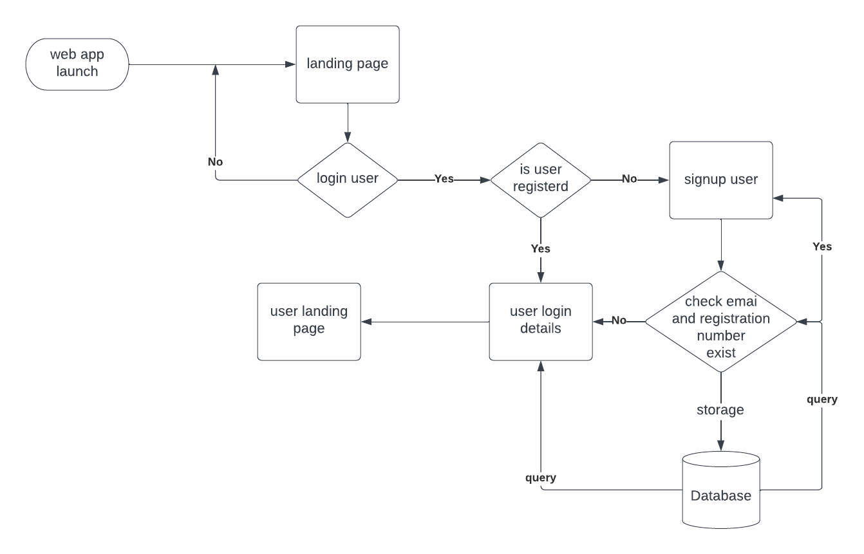**

**4.6.2 Context Diagram for online student logbook management system**

**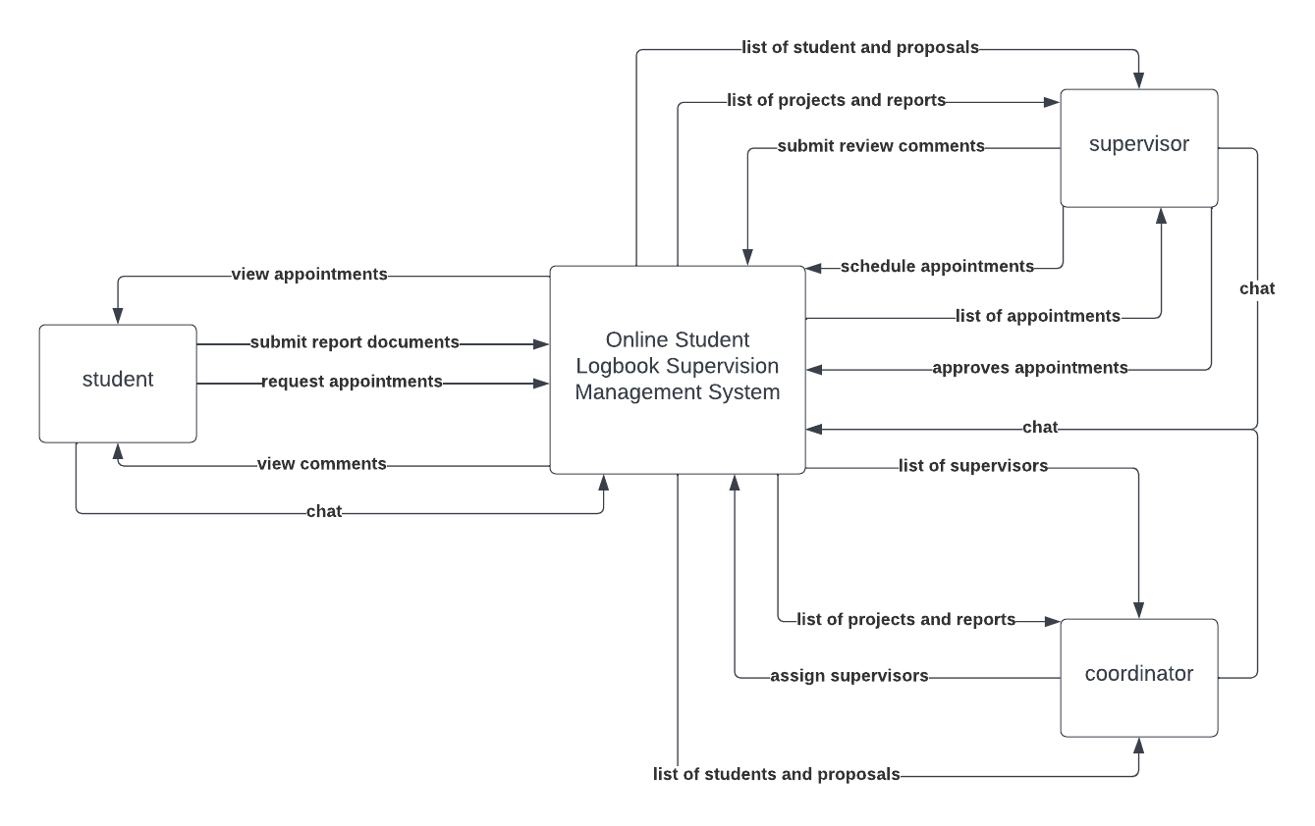**

**4.6.2 Data Flow Diagram for online student logbook management**

**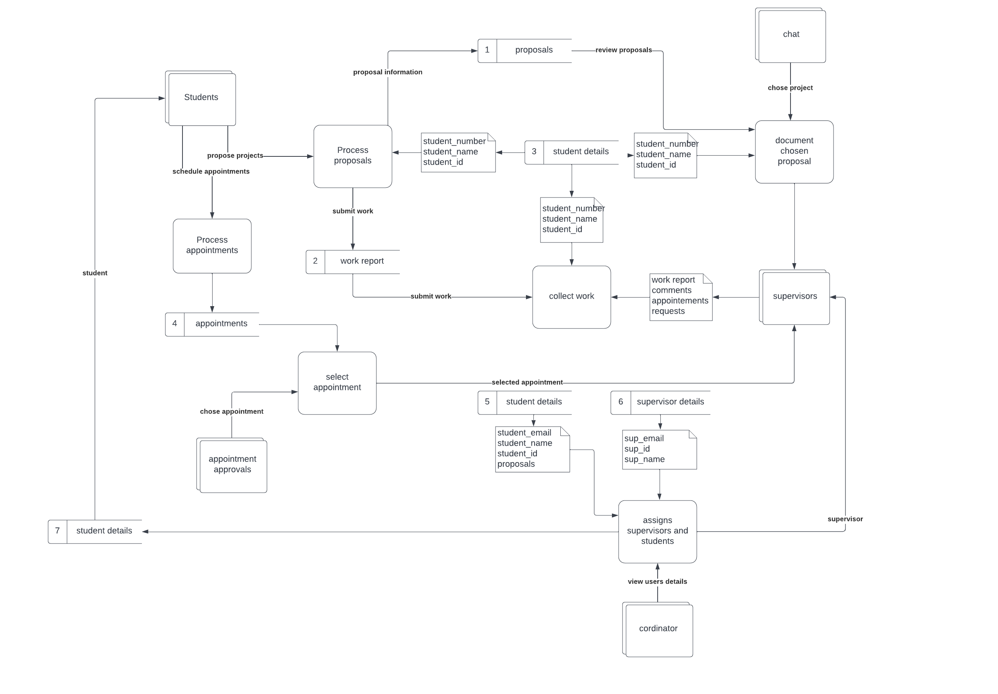**

**4.6.2 Sequence diagram login for online student logbook management**

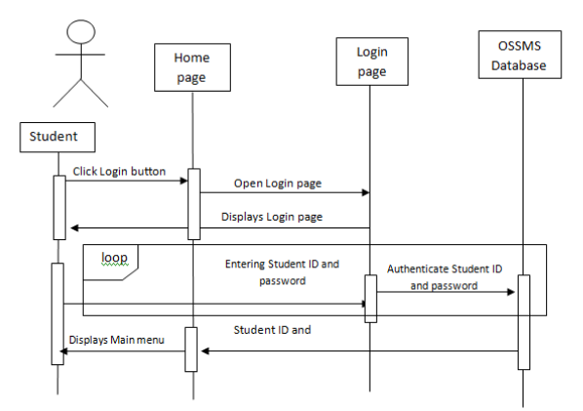

**4.7 CHAPTER SUMMERY**

We have discussed system analysis of the proposed systems by identifying the various components and functionality of the system. We have employed data flow diagrams and flowcharts to identify the technical flow of the entire system. All these to show that the user requirements were fully taken into consideration. Quality attributes of the system can be viewed diagrammatically. The feasibility study was also done to establish how viable the system is to the end user.

**CHAPTER 5: SYSTEM DESIGN**

**5.1 CHAPTER INTRODUCTION**

System design is the process of designing the various elements of a system and these include architecture, components and modules, user interfaces of modules and the data that is input in the system.

* **Architecture –** a conceptual model that defines structure, behaviour and more views of the system
* **Modules –** components that handle one specific tasks in a system. A system is composed of a combination of modules.
* **Components –** provide a particular function or group of related functions. They are made up of modules.
* **Interfaces –** a shared boundary across which the components of the system exchange information and relate.
* **Data –** a management of the information and data flow.

**5.2 DESCRIPTION OF THE PROPOSED SYSTEM**

The proposed system is a final year project supervision system that manages operations done during the final year project development. It comprises of three main modules for the three main users i.e., the Coordinator, Students, and Supervisors. It provides resources such as:

* Students
  + Are able to register and login to their portal
  + Are able to chat with their respective supervisors
  + Are able to view appointments from the supervisor
  + Are able to schedule appointments to the supervisor
  + Are able to upload report writing progress
  + Are able to view report remarks
  + Are able to link project progress on cloud
  + Are able to view project remarks
  + View logbook files and progress
* Supervisors
  + Are able to register and login to their portal
  + Access and edit a logbook file
  + Are able to chat with students
  + Are able to download reports
  + Are able to remark reports
  + Are able to review project progress
  + Are able to remark project progress
  + Are able schedule appointments
  + Are able to approves scheduled appointments
  + Pose a public notice
* Coordinators
  + Are able to login to their system
  + Manage final year project supervision
  + Review project progress
  + Review own profile

A number of extra features provided by the proposed system include:

* Search engine optimization
* Multi-user authentication
* Project comments

**5.2.1 STRENGTH OF THE PROPOSED SYSTEM**

* The system is conveniently available on the web and can be accessed via a computer device with internet connectivity.
* The system stores data that can be manipulated and utilized with ease by the data administrator.
* The system is easy to use and saves on certain costs e.g., unnecessary trips to the school for physical interaction due to reduced number of physical interactions between the supervisor and the student.
* The supervisor can pose a public notice to his/her students
* The system schedules appointments that can be reviewed by both the supervisor and the student.
* Registered users can monitor their progress through respective portals
* Users can comment on particular projects and comments can be managed.
* Users’ profile can be created and edited as per the user’s wish.
* The system is able to authenticate multiple users to their respective resources. This increases security through abstraction
* Users' passwords are encrypted hence improving more security
* Instant notifications via the emails to students.
* Historical data of each student is logged for future references.
* Paper based logbook reduction is relatively proportion to increase of trees.

**5.2.2 WEAKNESS OF THE PROPOSED SYSTEM**

* In case of bad internet connectivity, the system will be slow or unavailable to users.
* Maintenance of the system requires human resource and technological updates that could prove costly.
* The system is only limited to final year students at the time of taking the unit.

**5.3 CONCEPTUAL ARCHITETURE OF THE PROPOSED SYSTEM**

A conceptual design is an abstract or high-level design which includes only the most important components and entities. The main goal of a conceptual design is to provide an understandable picture of the overall purpose of the proposed solution. Components may include major technology systems, external systems that are required for integration or overall functionality, high level data flow, and system functionality. Think of this as the “black box” diagram where portions of the diagram may be simply a technology component to-be-named-later but is identified with its role and purpose.(TechieDolphine).

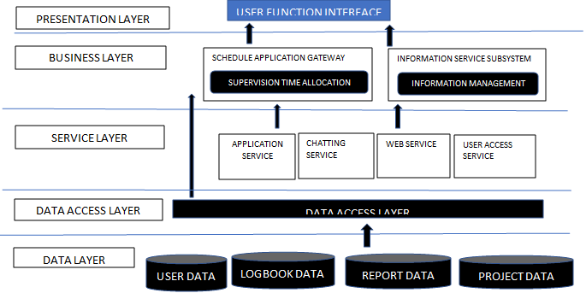

**5.4 DATABASE DESIGN OF THE PROPOSED SYSTEM**

**5.4.1 ENTITY RELATIONSHIP MODEL**

**5.4.2 Data dictionary**

**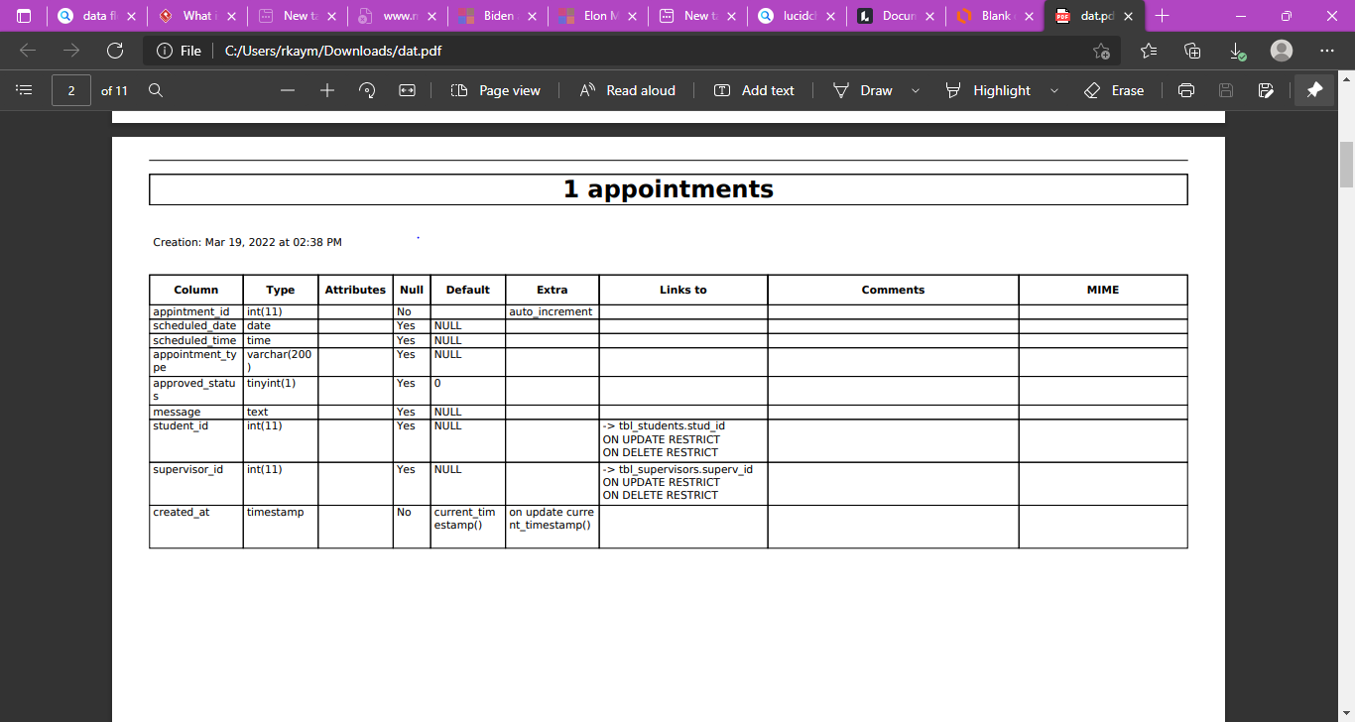**

**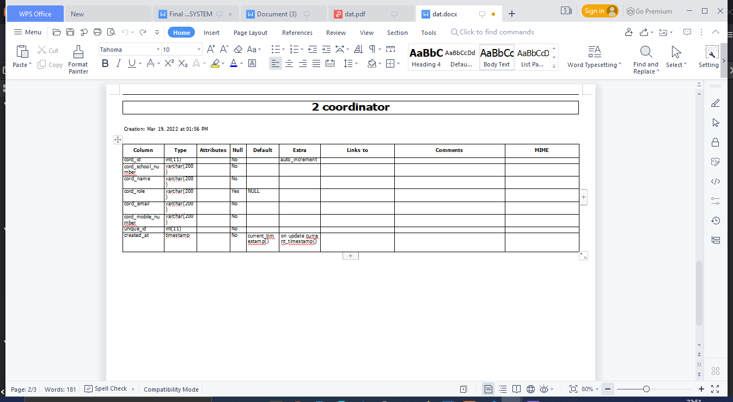**

**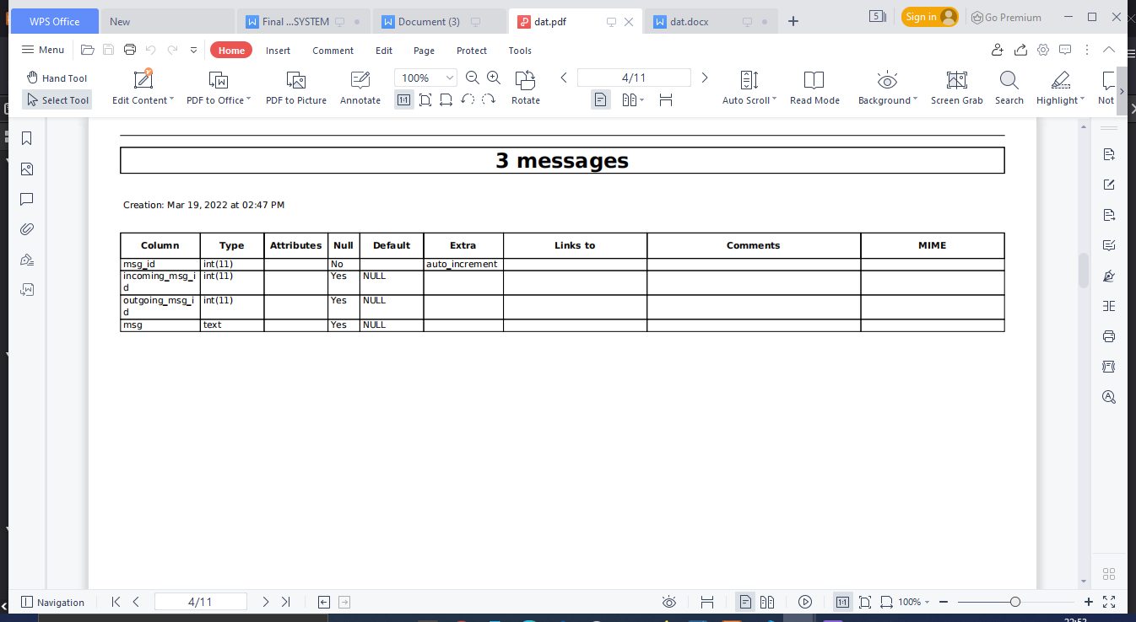**

**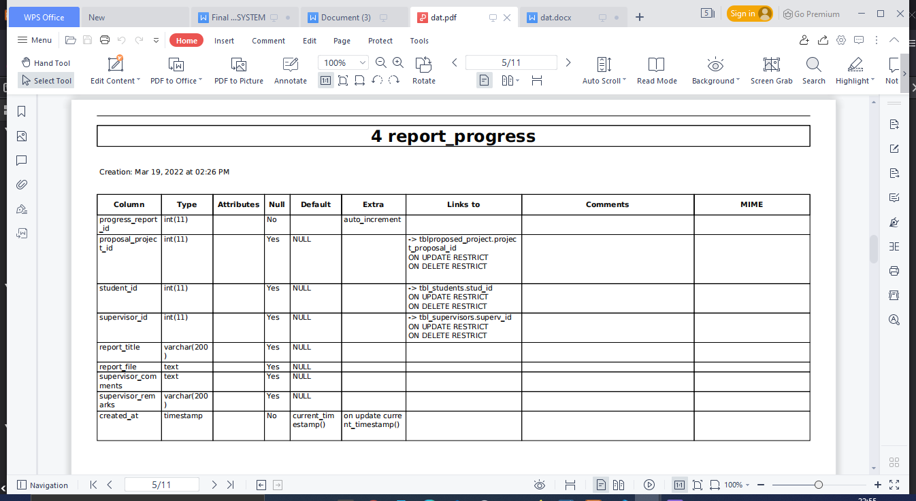**

**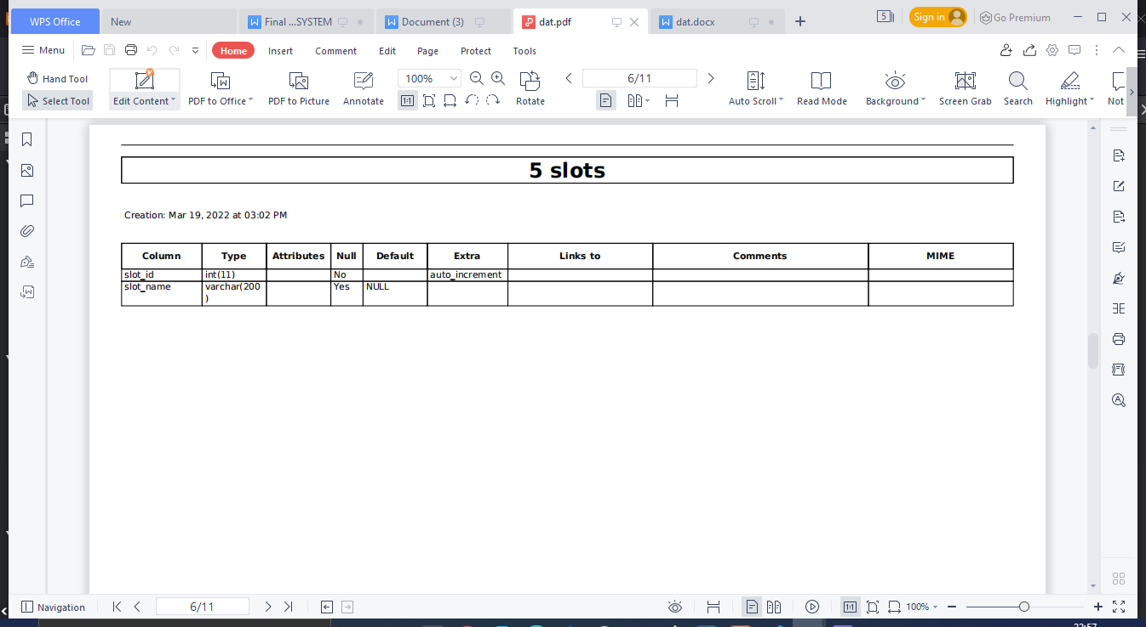**

**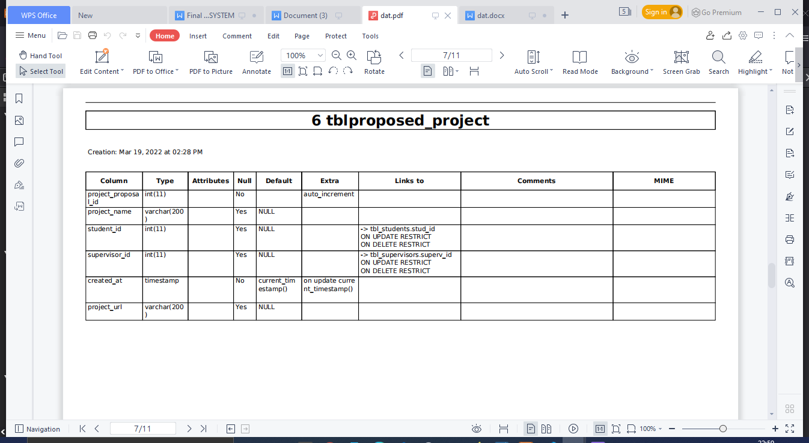**

**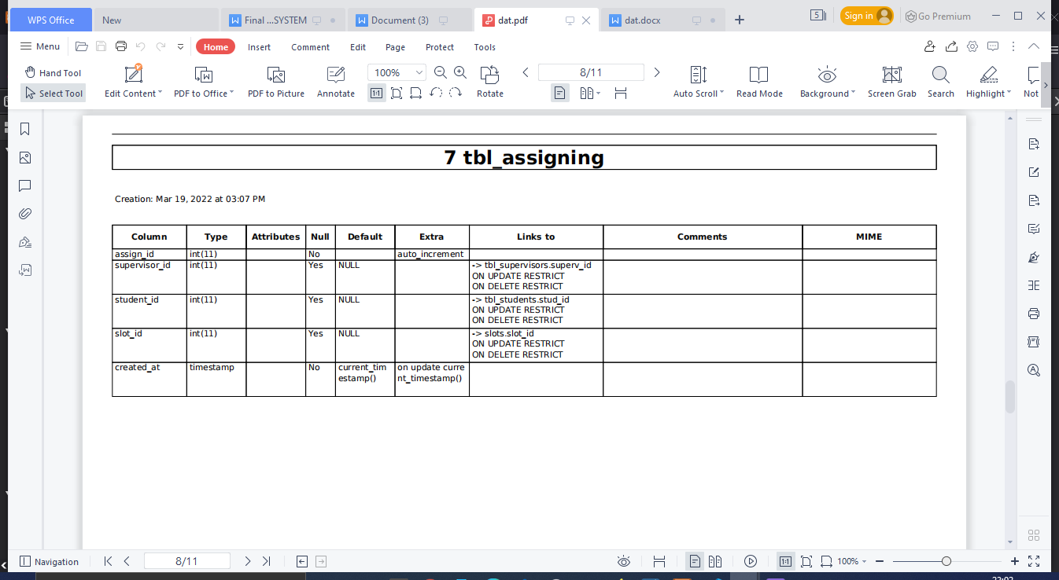**

**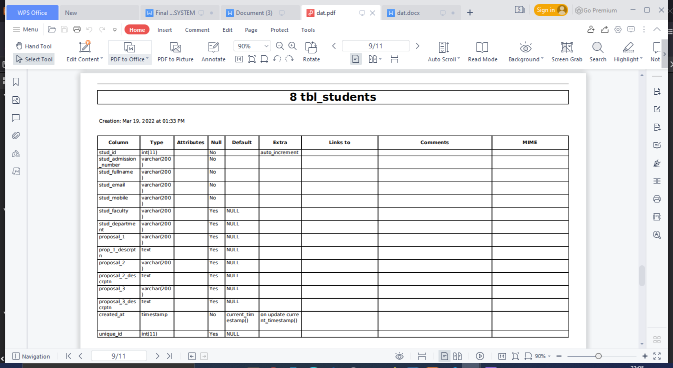**

**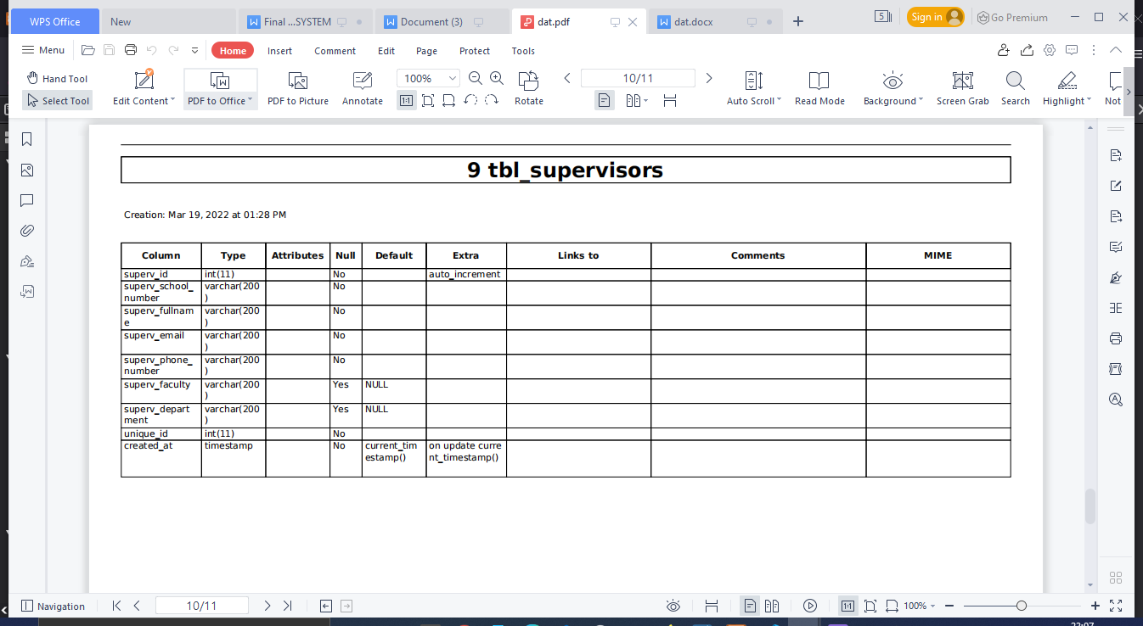**

**5.4.3 Database schema**

**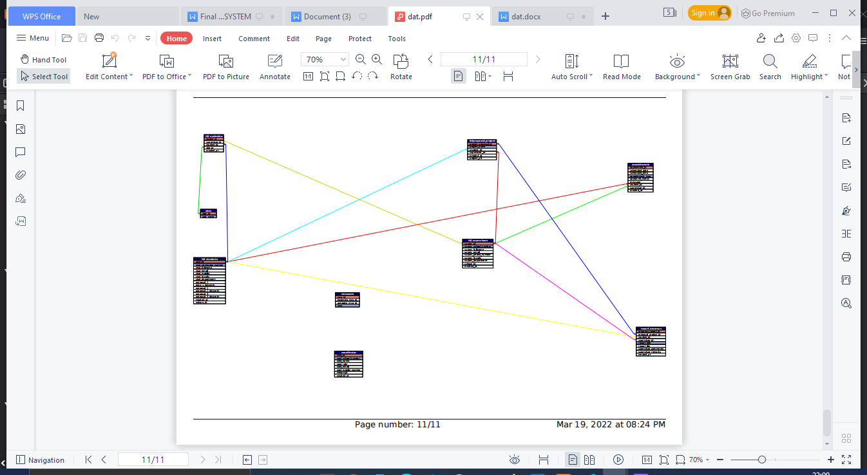**

**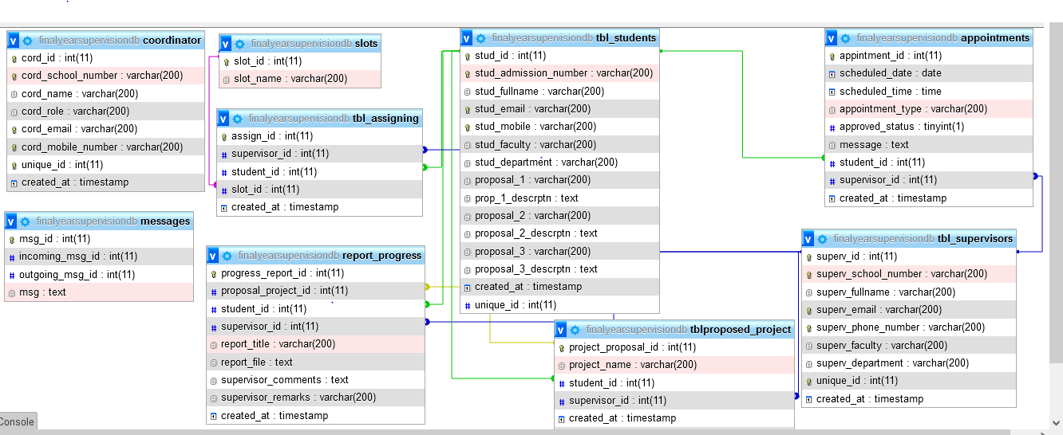**

**5.4.4 INPUT-PROCESS-OUTPUT MODEL OF THE PROPOSED SYSTEM**

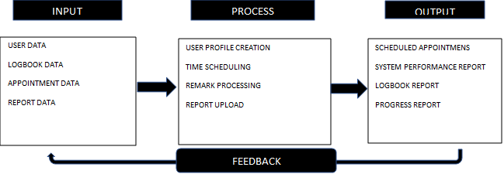

**5.5 CHAPTER SUMMARY**

This chapter has touched on the architecture of the proposed system which gave a diagrammatic representation of data in relation to components and modules. The system’s database was also presented using the entity relationship diagram and shows how the various tables are related through primary keys, and the existing of the type of relationship between tables: One-to-One, One-to-Many, and Many-to-Many relationship can be seen in our model. In a nutshell the input-process-output process gave a summary of the overall system too in regards to input data, process tasks, output data and feedback information of the processed data.

**REFERENCES**

1. Loci Solutions Group Pty Limited, 2014. 7 disadvantages of paper-based document management. Solutions Group Pty Limited, Sydney. http://www. locisolutions.com/blog/7-disadvantages-paperbased-document-management
2. National Research Council, 1999. Industrial Environmental Performance Metrics: Challenges and Opportunities. National Academic Press, Washington, USA., ISBN 13: 9780309062428, Pages: 264.
3. W3C., 2016. HTML & CSS. World Wide Web Consortium, Cambridge, Massachusetts, USA. https://www.w3.org/standards/webdesign/htmlcss.
4. Pluralsight, 2015. What’s the difference between the front-end and back-end?. Pluralsight,Farmington, Utah, USA. https://www.pluralsight.com/blog/filmgames/whats-difference-front-end-back-end
5. French, A.M., 1970. Web development life cycle: A new methodology for developing web applications. J. Internet Banking Commerce, 16: 1-11